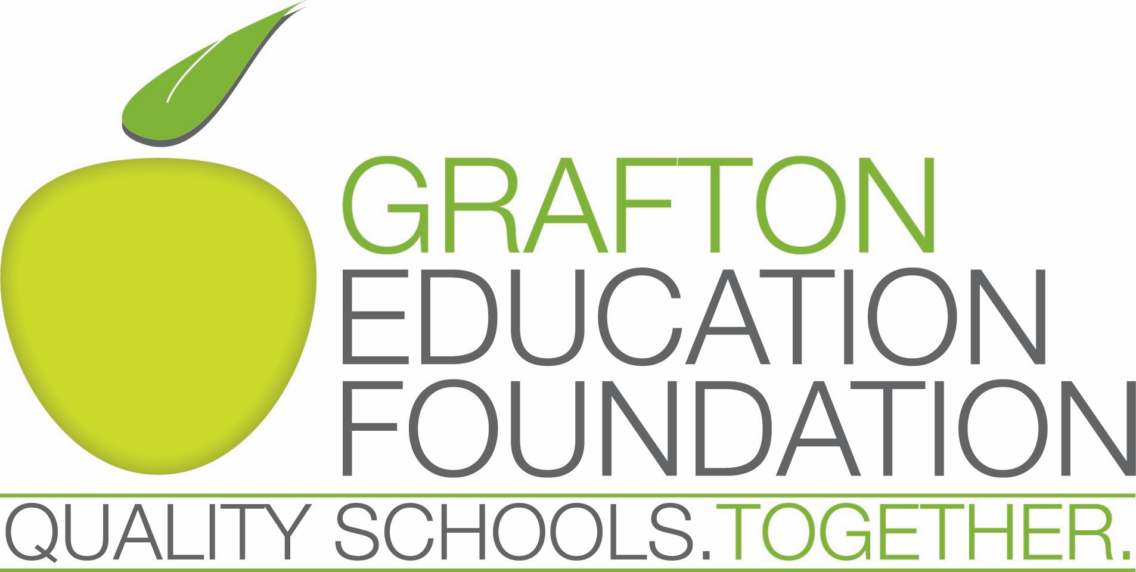

Grafton Education Foundation Student Ambassador Program

The Grafton Education Foundation (GEF) is a 501(c)(3) non-profit created to address funding gaps for educational programs throughout the four public schools in Grafton. GEF’s mission is to enhance and enrich educational opportunities for Grafton public school students in all grades. We will encourage increased partnerships with the community, local businesses and schools. That's why we say: Quality Schools. Together.
The GEF welcomes any interested Grafton High School Student to its volunteer committee, open to Sophomores, Juniors and Seniors. The students serve a minimum, one - year term (September – August) and are active volunteers. The Student Ambassadors are encouraged to attend board meetings (held on the third Monday of every month from 7pm – 8pm), join other volunteer committees and support board initiatives. Ambassadors will play a part in organizing the GEF’s fundraising and community events and may be asked to coordinate high school volunteers for various events.
How to apply: Potential Student Ambassadors can submit applications to the GEF which will be reviewed by the GEF Board members. Applicants should submit their applications at info@graftoneducationfoundation.org and include a reference letter from a GSD teacher who has had direct contact with the student, and a brief statement (up to 250 words) describing their interests and reasons for wanting to serve as a Student Ambassador. Applications are due by September 30th. For further inquiry and applicant submission, please contact Karen Powell at info@graftoneducationfoundation.com.

GEF Student Ambassador Application

Name:

Address:

Phone Number:

Email:

Graduation Year:

Email the completed form along with teacher reference letter and student statement (up to 250 words describing your interest and reasons for wanting to serve as a Student Ambassador) to:
info@graftoneducationfoundation.com

